
The Nutcracker

Choreography: Janek Schergen
Music: Peter Ilyich Tchaikovsky
Costume and Scenic Design: Aaron Yap
Lighting Design: Suven Chan

Esplanade Theatre | 9th December 2011, 8pm

Overture

Prologue

Act One
Scene One The Party
Scene Two The Battle
Scene Three The Land of Snow

Interval

Act Two
The Kingdom of the Sugar Plum Fairy

Prologue
In Shanghai, on the 24th of December, a group of close friends are preparing themselves for a large party to be hosted by the well-respected family, the Nightingales. Along the Bund, everyone is rushing from one shop to another to get their last minute things to prepare for the evening’s celebrations. Mr. Nightingale stops at a jewellery shop where he has chosen a magnificent diamond necklace to present to his wife as a token of his affection.

Act One Scene One - The Party
Christmas is not a usual holiday but Mrs. Nightingale is using it as a time for a celebratory party. The Nightingale children are more concerned with their own presents and the friends coming to the party than their parents can appreciate. Marie, the oldest, feels bored by all the fuss. As Mrs. Nightingale’s parents and all the guests arrive, a rather aristocratic gentleman, Drosselmeyer, enters with his nephew, Kristian, and four of his schoolmates. Three exotic Russian ballerinas, on tour with the famous Russian Ballet also arrive. They have been invited to be an entertaining divertissement for the party.

Drosselmeyer’s close friend, a magician, is also a guest and demonstrates an amazing performance of magic for everyone at the party. Drosselmeyer has presented the youngest daughter, Clara, with a German Nutcracker as a gift which he had cast a spell on. The evening ends with the usual rituals of thanks and goodbyes and everyone goes on their way happy and joyous.

Act One Scene Two - The Battle
The party is over and it is long past her bedtime, but Clara is still awake. She comes back downstairs to look for her Nutcracker and the spell begins to unfold. Suddenly, the house seems to be overrun by mice taking all the food and presents and causing great mischief. As all this takes place, the Christmas tree grows to a huge height! Drosselmeyer returns with Kristian and his four friends, now as handsome soldiers, to protect Clara. A fierce battle ensues between the mice and the soldiers. Kristian, with Clara’s help, leads his battalion to victory and drives the mice from the house.

Act One Scene Three - The Land of Snow
As a reward Clara is taken on a magical journey to the Land of Snow where she meets the Snow King and Queen and all her snowflake subjects.

Act Two - The Kingdom of the Sugar Plum Fairy
Clara continues her journey further until she arrives at the magical Kingdom of Sweets. Clara’s sister, Marie and Kristian, greet her as the Sugar Plum Fairy and her Prince Consort. Everyone from the Land of Sweets comes to entertain Clara with wondrous dances.

As the night fades Clara finds herself waking from her sleep on the sofa with the Nutcracker at her side. She cannot tell if the magical journey she took was a dream or some magic of reality. She sees that overnight it has snowed outside and takes this as assurance that everything happened just as she remembers.

Patron
H.E. Dr. Tony Tan
President of the Republic of Singapore
Founders
Mr. Anthony Then
Ms Goh Soo Khim
Chairman
Mr. Michael Hwang
Board Members
Mr. Edward D’Silva
Ms Goh Soo Khim
Mrs. Laura Hwang
Mr. David Lim
Mr. Desmond Ong
Mr. Daniel Teo
Artistic Director
Janek Schergen

Swan Lake
15-18 March
Esplanade Theatre
Premiered in December 2007, the Singapore Dance Theatre’s Swan Lake was warmly received by both critics and audiences, with Dance Europe calling it “a valiant effort” and an indication that the company is “capable of competently presenting one of the classics of the
ballet repertory”.
Swan Lake tells the story of Princess Odette being turned into a swan by an evil sorcerer’s curse and how the true love of Prince Siegfried breaks the curse. This re-staging will once again be helmed by the company’s Artistic Director Janek Schergen.

Ticket Prices
$90, $75*, $50 & $30
*$50 Concession price for full-time student / NSF /Senior Citizen

Tickets available on sistic.com
Hotline: 6348 5555

Other discount promotion available, please visit www.singaporedancetheatre.com for more
information.

Tickets will be on sale from 12 January 2012.

Patron Sponsor


Silver Anniversary Sponsor


Official Airline



Official Credit Card



Official Privilege Card

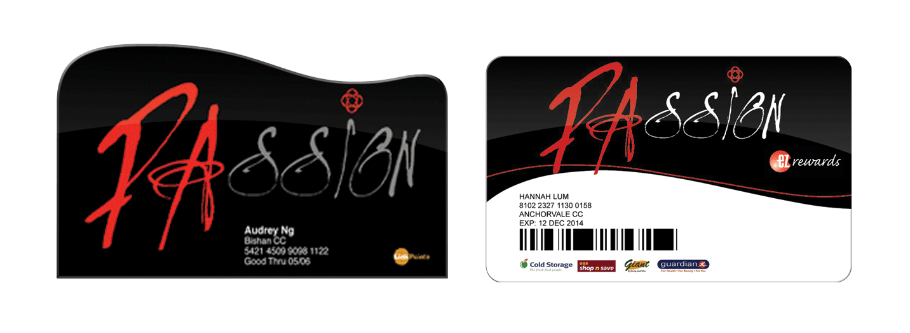

Official Dancewear



Season Sponsor



The Nutcracker

Choreography: Janek Schergen
Music: Peter Ilyich Tchaikovsky
Costume and Scenic Design: Aaron Yap
Lighting Design: Suven Chan

Esplanade Theatre | 9th December 2011, 8pm

CAST

Act I, Scene I
Mrs. Nightingale Madeleine Halbauer
Mr. Nightingale Chen Wei
Mdm. Tang Elynn Chew
Mr. Tang Lim Choon How
Marie Heidi Zolker
Fritz Lee Wai Hong
Clara Natalie Ng

Drosselmeyer Mohamed Noor Sarman

Kristian Timothy Coleman
Kristian’s Friends Shaw Coleman Etienne Ferrère
Tatsuro Kannan
Ryo Suzuki

Aunt – Mdm. Ching Amy Bale
Mei Yan Sae Bosco
Mei Yi Sherry Leow

Maid Li Jie

Butler Timothy Ng

Russian Ballerinas
Marie Iori Araya
Anna Nonoko Tanaka
Olga Chihiro Uchida

Banker – Mr. Lee Robin Lawrence Kent
Mdm. Lee Elaine Heng
Lee Juan Rachel Ong
Lee Yee Renee Teo
Lee Mei Natasha Magad

Shopkeeper – Mr. Sung Zhao Jun
Mdm. Sung Alison Carroll
Sung Wei Stine Emilie Tinsfeldt
Sung Lian Hana Bermingham

Mayor – Mr. Wu Michael Wong
Mdm. Wu Tomoko Takahashi
Wu Hao Matthew Ng
Wu Yu Ashley Lim

Ambassador Kensuke Yorozu

Mlle. Shen Cheah May Yen
Theo Jan Werner
Amelia Siti Farahnazirah

Magician Jazz Ang

Scene II
Mouse King Francis Jaena Jr

Little Mice Andrea Cher
Sarah Cher
Kimberley Chia
Amelia Inkster
Samantha Tang

Big Mice Rachel Chan
Jaimie Ford
Felicia Lim
Angelica Tan
Vanessa Tan
Joelynne Woo

Soldiers Jill Goh
Natasha Magad
Elaine Ng
Nura Wong

Scene III
Snow Queen Rosa Park
Snow King Chen Wei

Icicles Nanase Tanaka
Kensuke Yorozu

Nonoko Tanaka
Zhao Jun

Snowflakes Iori Araya
Amy Bale
Alison Carroll
Cheah May Yen
Elynn Chew
Madeleine Halbauer Elaine Heng
Jessica Larbig
Li Jie
Akira Nakahama
Chihiro Uchida
Xu Lei Ting

Act II
Sugarplum Heidi Zolker
Cavalier Timothy Coleman

Spanish Nanase Tanaka
Zhao Jun
Spanish Girls Jill Goh
Regina Henares
Lee Kai Wei
Vanessa Lim
Low Jiaxin
Nura Wong

Shepherd Robin Lawrence Kent
Shepherdess Li Jie

Chinese Flowers Elynn Chew
Iori Araya

Toy Soldiers Shaw Coleman
Etienne Ferrère Tatsuro Kannan
Ryo Suzuki

Dolls Hana Bermingham
Amelia Inkster
Siti Farahnazirah
Angelica Tan
Samantha Tang
Stine Emile Tinsfeldt

Teddy Bears Sae Bosco
Rachel Chan
Sherry Leow
Natasha Magad
Isadora Ou
Joelynne Woo

Dewdrop Tomoko Takahashi
Flowers Amy Bale
Alison Carroll
Cheah May Yen
Lisha Chin
Madeleine Halbauer
Elaine Heng
Jessica Larbig
Akira Nakahama
Mina Niikura
Nonoko Tanaka
Chihiro Uchida
Xu Lei Ting

Casting is subjected to changes. Information is correct at the time of printing.

Official Fitness Partner


Official Legal Consultant


Official Radio Station


Partner



Supported by


Official Photographer


