If There’re Seasons
The Theatre Practice
3 – 20 April 2014, Drama Centre Theatre

Production information

This is the third production of one of The Theatre Practice’s most acclaimed works. After two previous sell-out versions, this acclaimed third is mounted with increased production values and assured performances, mostly with the original cast. If There're Seasons is an unique and original musical, entirely in Mandarin and follows the successes of Liao Zhai Rocks! and Lao Jiu, the Musical; building for The Theatre Practice a strong foundation in the production of local musicals.
The third season of this popular work proves its significance; and, by box office returns alone, arguable puts it at the top of the list of Singapore musicals, ahead of the famed Beauty Queen and Chang and Eng, both in English. The success of If There're Seasons lies in it being a dramatic interpretation of the best songs of renowned Singapore songwriter, Liang Wern Fook, who almost single-handedly started the xinyao* movement in the ‘80s. However, it is not a ‘juke-box’ musical, because Liang Wern Fook wrote a number of new songs especially to create this work with famed Hong Kong script writer, Raymond To.
This large-scale work is lavishly mounted under the direction of The Theatre Practice’s Artistic Director, Kuo Jian Hong, with new musical arrangements by Bang Wenfu, choreography by Okorn-Kuo Jing-Hong, sets designed by Wang Chee Wai - all under the musical direction of Julian Wong. Full of characters, melody and story-lines, the work is both nostalgic and contemporary in its warm-hearted embrace of Singapore concepts and lifestyles.
The Theatre Practice was established in I965, slightly older than Singapore by more than a month: it has built a niche on bi-lingualism and a dedication to the local repertoire and its international importance. Introducing classics as well as original creations, the company strives to inject local flavor, while remaining open to possibilities in the global arena. The Theatre Practice has also been a pioneer in Arts Education, bringing countless workshops and performances into schools, and nurturing several generations of Singaporeans.

155 Waterloo Street, #02-08 Stamford Arts Centre Singapore 187962
Tel 6337 2525. www.practice.prg.sg
ttp@practice.org.sg

*Xinyao is a Chinese noun of two words meaning Xin (short for Singapore) and yao for ‘song’. It is a distinct genre of ‘Singaporean music’ characterized by simple melodies and poetic lyrics about homeland and the lives of Singaporeans.

(Synopsis and Themes)
After the demise of his girlfriend Jing, A-Le packs up to pursue his musical ambitions in New York. There he meets the easy-going A-Qiang, a fellow dream hunter from Singapore, who gets him a job at a restaurant. On a particular takeout delivery, an aspiring actress named Rose enters A-Le's life. Soon a bittersweet friendship of battered dreams and bruised hearts is born amongst them. But with each passing day, Rose begins to feel a little more for A-Le. Unknown to them however, the future is about to change their lives and their friendship forever.
"There are no seasons here, but there is always love......"
The story revolves around Ah Le, Ah Qiang and Rose, who meet up in New York, all searching for their dreams and nursing a wound from their previous lost love. This group of young friends share their love for music, and battle with reclaiming their old loves.
Uniquely portraying the nation’s dreams through Singaporeans living far from home, the need to love and to be loved is a constant theme, as the past and its memories have to be appeased before people can move on with their new lives. Old ties of the heart are not just to people but also to place; this work is not only about meaningful relationships but also reflects Singapore today and the ways it is loved, both locally and internationally.

CAST
A-Le . . . . . . . . . George Chan
Rose . . . . . . . . . Joanna Dong
A-Qiang . . . . . . . . . Ric Liu
Xiao Jing . . . . . . . . . Celine Rosa Tan
Jun Qiang . . . . . . . . . Oliver Pang
Uncle Cheng . . . . . . . . . Lim Kay Siu
Xiao Song . . . . . . . . Erwin Shah Ismail
Xiao Jiang . . . . . . . . . Marc Valentine Chia
Kitchen Uncle . . . . . . . . . Gan Yeok Thiam
Dishwashing Auntie . . . . . . . . . Goh Guat Kian
Ensemble . . . . . . . . . Jodi Chan, Edward Choy, Deng Chen Chao,
Hung Chit Wah Felix, Hang Qian Chou,
Zachary Ho, Lee Qian Yu, Candice de Rozario,
Jo Tan, Tay Wei Liang, Ethel Yap
Robert . . . . . . . . . Chad O’Brien
Hip Hop Girl . . . . . . . . . Gabrielle Evelena Ferdinands, Tiffany Tallon
Break Dancer . . . . . . . . . Yumida Sumitra (Boy)
Children . . . . . . . . . Deng Chen Chao, Lee Qian Yu, Ethel Yap
(Cast A)
Marcel Sebastian Bek Gotsmy,
Nadine Bastienne Bek Gotsmy,
Victoria Sung Yushin,
Lauren Yeo
(Cast B)
Olivia Yi-Le Hatton, Tan Kai Rui, Toh Yun Woon,
Toh Keow Woon

MUSICIANS (The Band)
Conductor . . . . . . . . . Julian Wong
Keyboardist . . . . . . . . . Tan Kian Wee
Accoustic & Electric Guitarist . . . . . . . . . Feri Susanto
Bassist . . . . . . . . . Colin Yong
Bassist (Rehearsal) . . . . . . . . . Din Safari
Percussionist . . . . . . . . . Patrick Ang
Violinist . . . . . . . . . Lim Hui

PRODUCTION
Composer/ Lyricist . . . . . . . . . Liang Wern Fook
Playwright . . . . . . . . . Raymond To
Director/ Co-Lighting Designer . . . . . . . . . Kuo Jian Hong
Music Arranger . . . . . . . . . Bang Wenfu
Choreographer . . . . . . . . . Okorn-Kuo Jing Hong
Music Director/ Additional Arranger . . . . . . . . . Julian Wong
Set Designer . . . . . . . . . Wong Chee Wai
Co-Lighting Designer . . . . . . . . . Genevieve Peck
Sound Designer . . . . . . . . . Shah Tahir
Hair Designer . . . . . . . . . Ashley Lim
M.A.C Creative Artist . . . . . . . . . Beno Lim
Production Manager/ Props Master . . . . . . . . . Chan Lee Lee
Stage Manager . . . . . . . . . Keira Lee
Assistant Stage Managers . . . . . . . . . Gong Zekun, Vivianne Koh
Lighting Programmer . . . . . . . . . Ismahadi Putra
Followspot Operators . . . . . . . . . Chia Run Jin (RJ), Chua Chin Soon Aldon,
Jasmine Wang
Sound Engineer . . . . . . . . . Sandra Tay
Radio Mic Operators . . . . . . . . . Ang Aik Siang, Ng Xin Yuan Melissa,
Jonathan Yeo Yong En
Surtitles . . . . . . . . . Dong Xin
Surtitles Operator . . . . . . . . . Goh Si Ting Denise
Video Editor . . . . . . . . . Sam Nai
Music Assistants . . . . . . . . . Lauren Koh, Joel Sim
Wardrobe Coordinator . . . . . . . . . Éclair Lim
Assistant Wardrobe Mistress . . . . . . . . . Karen May
Wardrobe Assistants . . . . . . . . . Aainaa, Valeree Ray Lee
Stage Assistants . . . . . . . . . Samantha Chia, Justina Hussain,
Joceline Loo Si Ying, Seah Wei Yang
Graphic Designer . . . . . . . . . Hui Shi Li
Programme Editor . . . . . . . . . Huang Suhuai
Programme Translator . . . . . . . . . Dong Xin
Photos of Cast and Production (appearing in the documentary photographs)

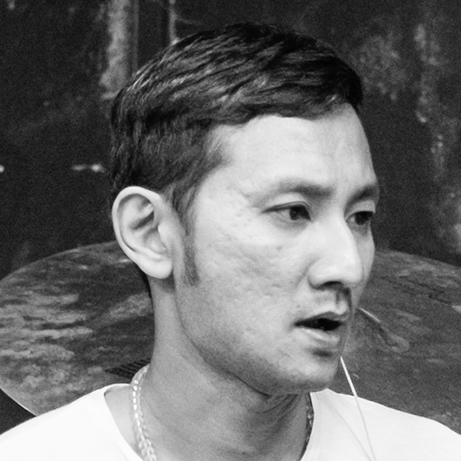  Patrick Ang | 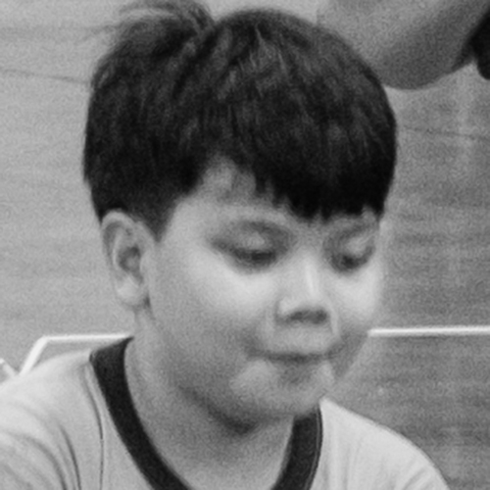  Marcel Sebastian Bek Gotsmy
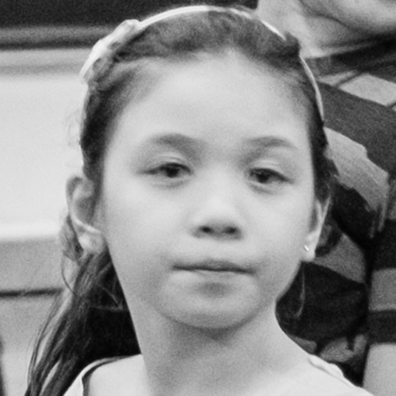  Nadine Bastienne Bek Gotsmy | 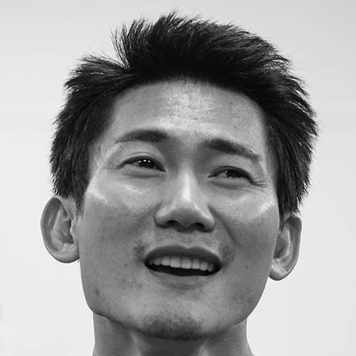  George Chan
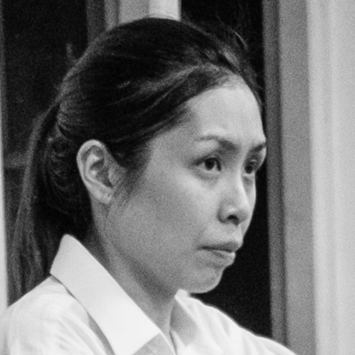  Jodi Chan | 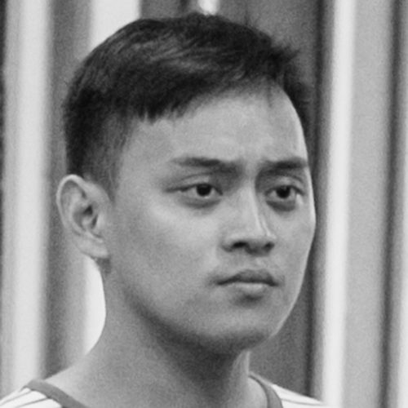  Marc Valentine Chia
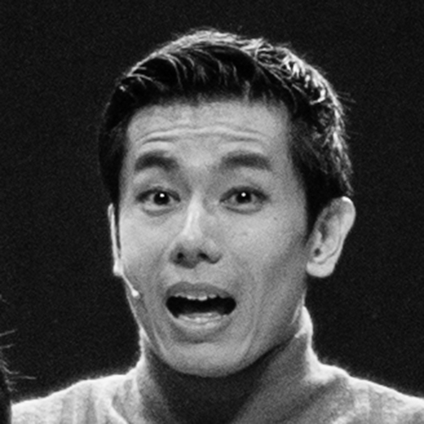  Edward Choy | 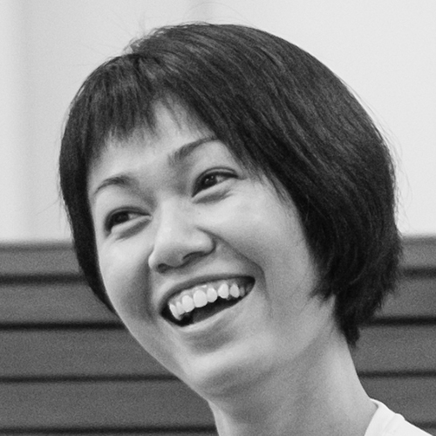  Joanna Dong
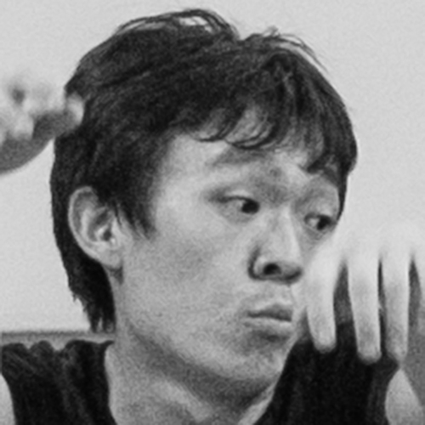  Deng Chen Chao | 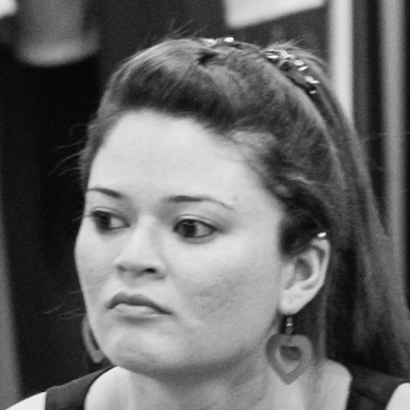  Gabrielle Evelena Ferdinands
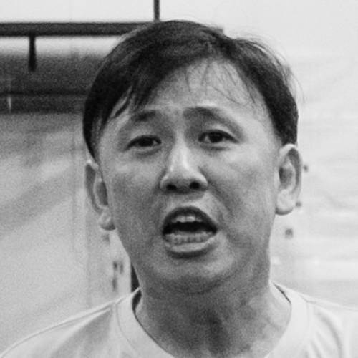  Gan Yeok Thiam | 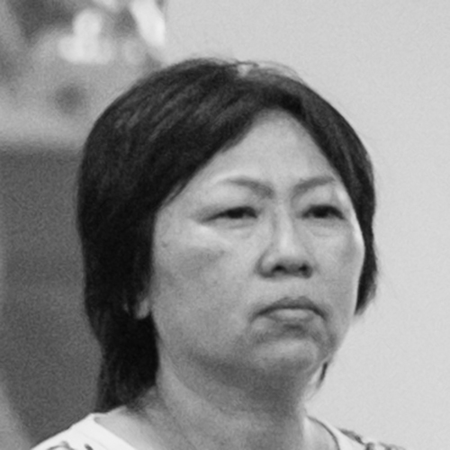  Goh Guat Kian
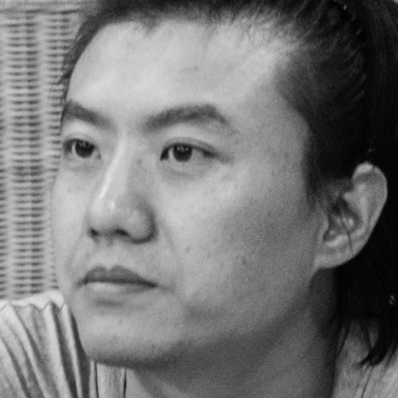  Gong Zekun | 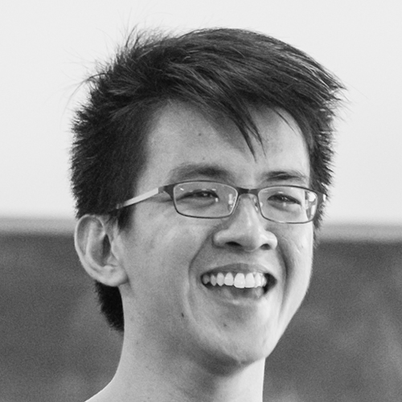  Hang Qian Chou
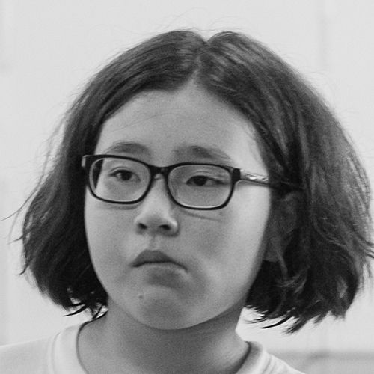  Olivia Yi-Le Hatton | 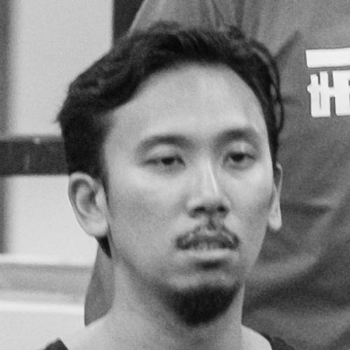  Zachary Ho
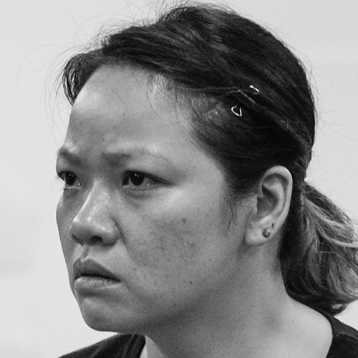  Hung Chit-Wah, Felix | 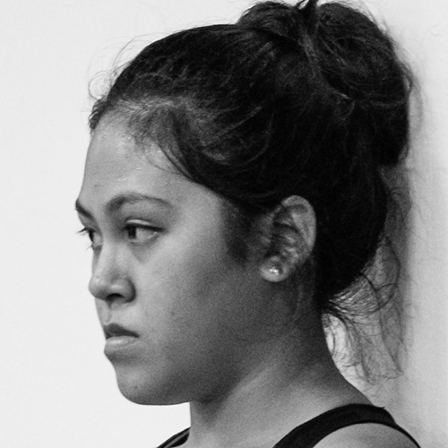  Justina Hussain
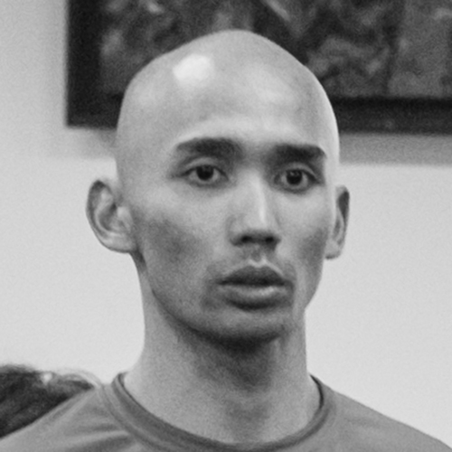  Erwin Shah Ismail | 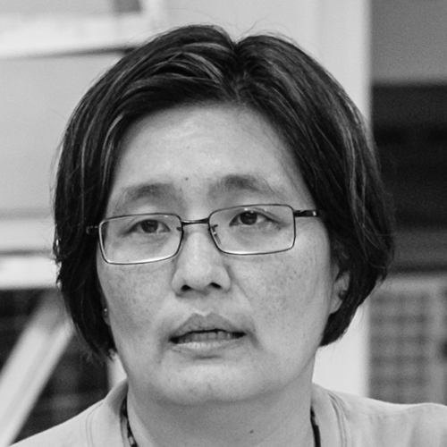  Kuo Jian Hong
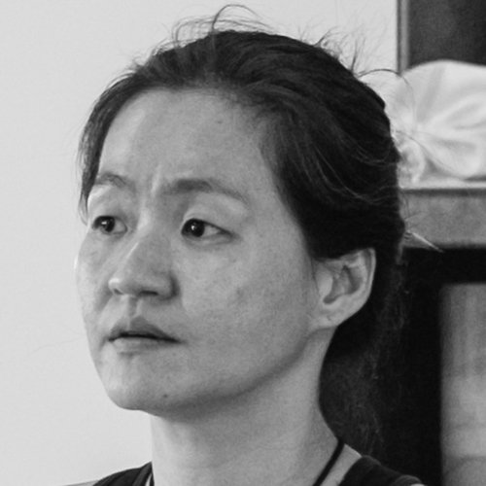  Okorn-Kuo Jing Hong | 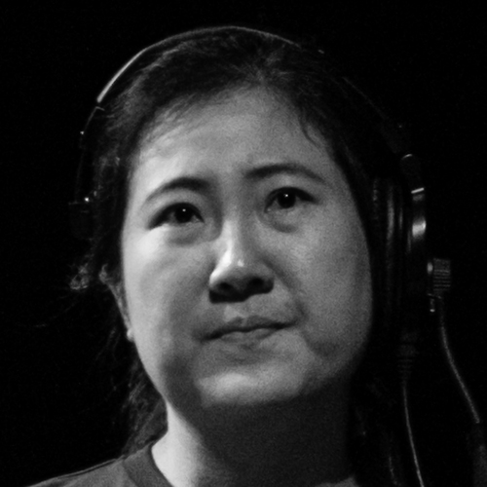  Vivianne Koh
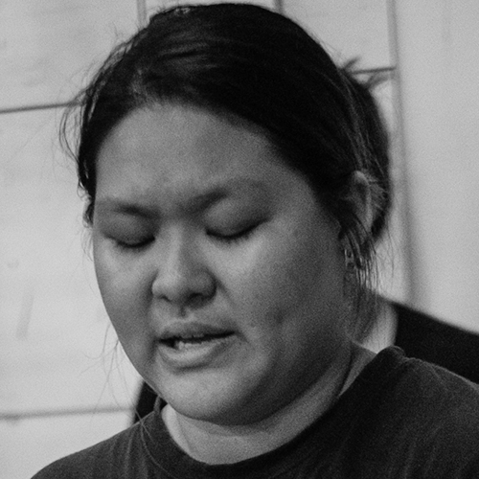  Keira Lee | 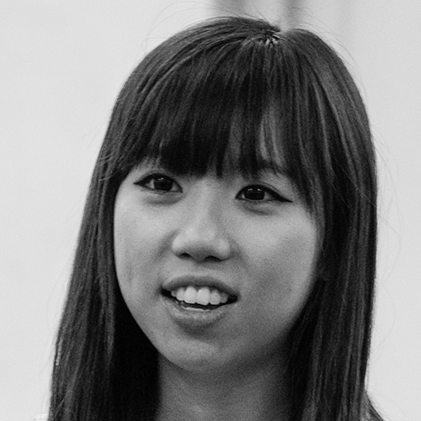  Lee Qian Yu
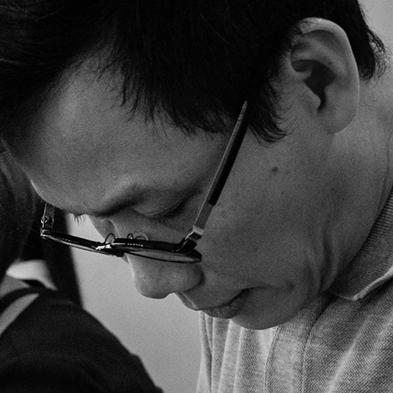  Ashley Lim |   Lim Hui
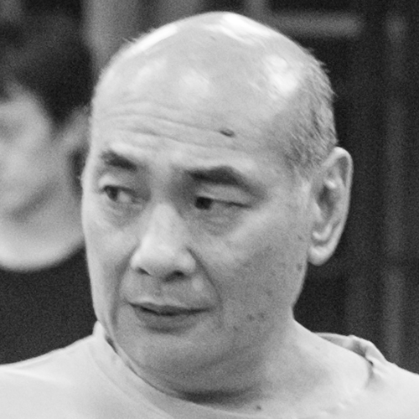  Lim Kay Siu | 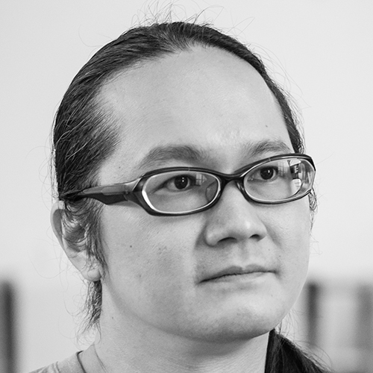  Ric Liu
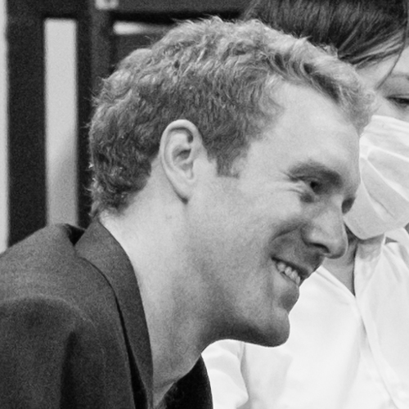  Chad O’Brien | 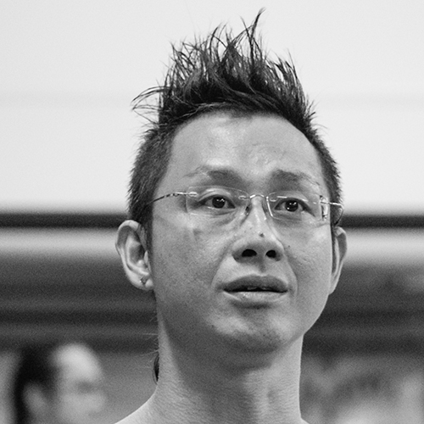  Oliver Pang
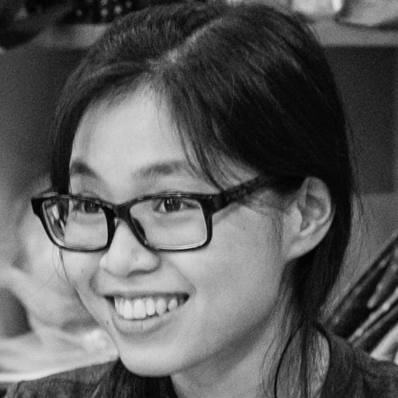  Genevieve Peck | 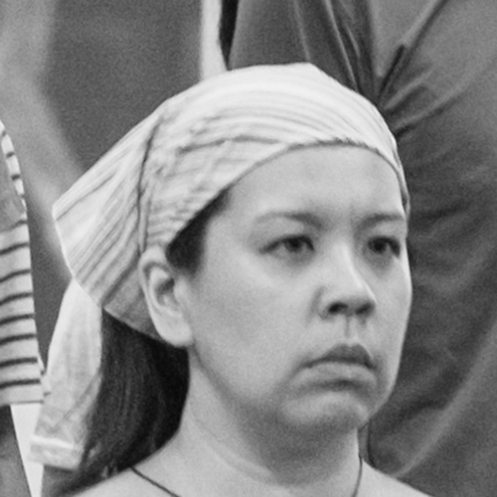  Candice De Rozario
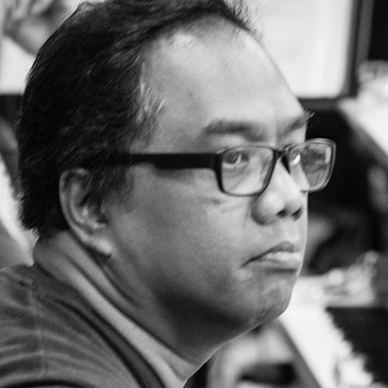  Din Safari | 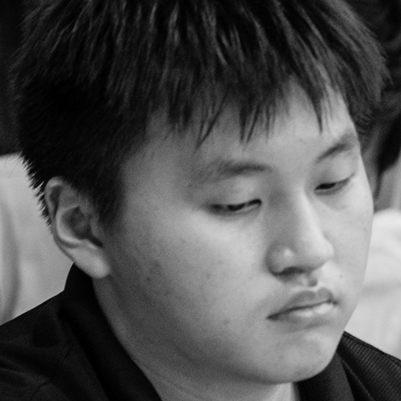  Joel Sim
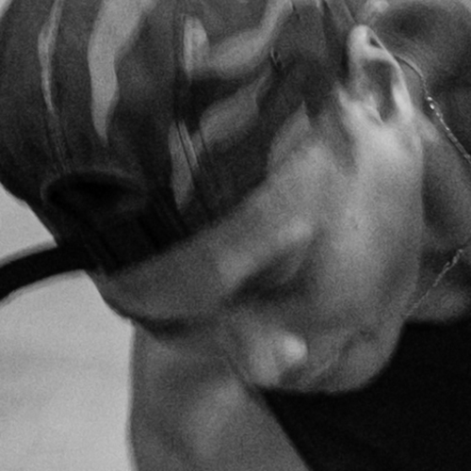  Yumida Sumitra | 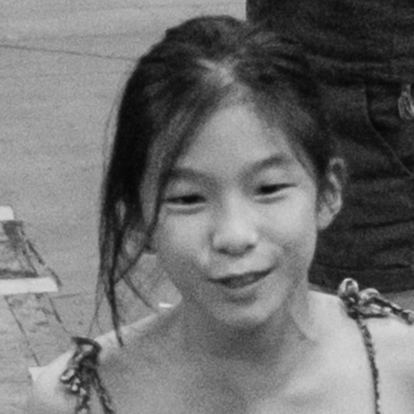  Victoria Sung Yushin
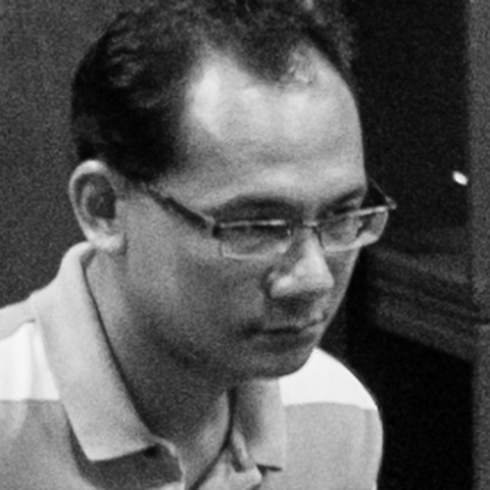  Feri Susanto | 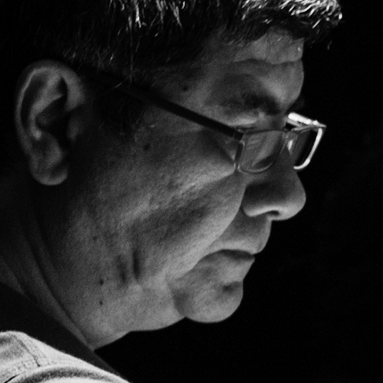  Shah Tahir
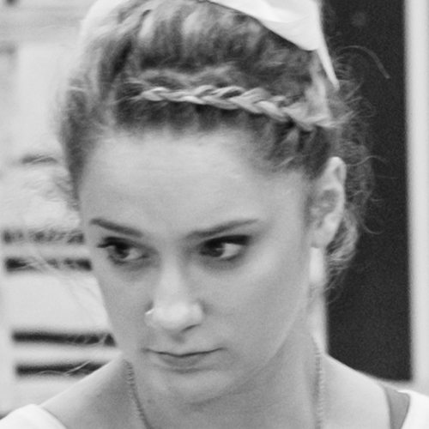  Tiffany Tallon | 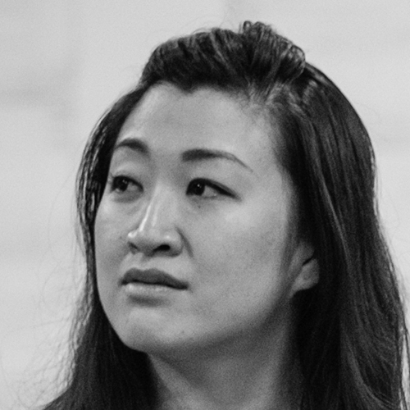  Celine Rosa Tan
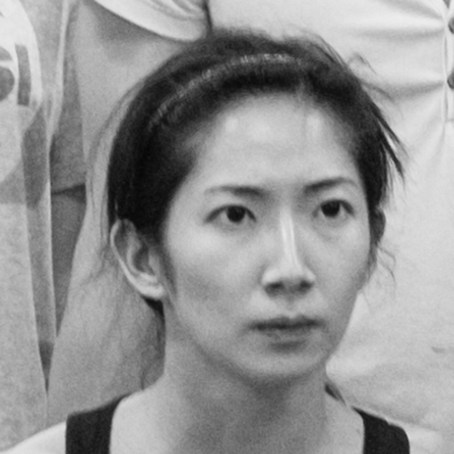  Jo Tan | 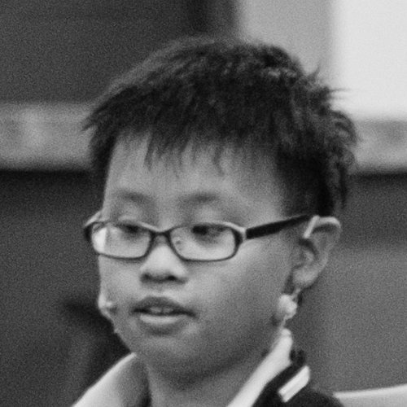  Tan Kai Rui
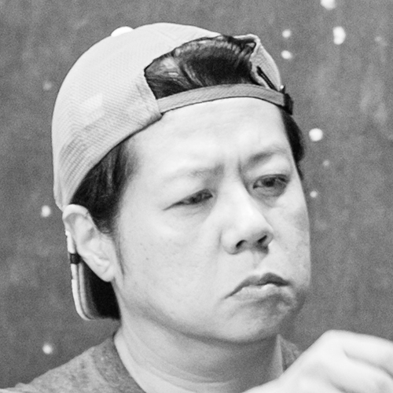  Tan Kian Wee | 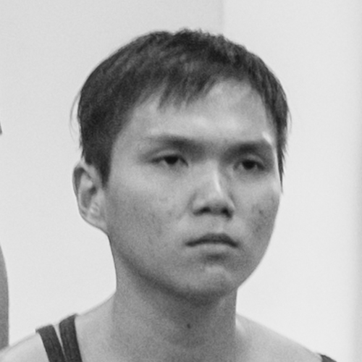  Tay Wei Liang
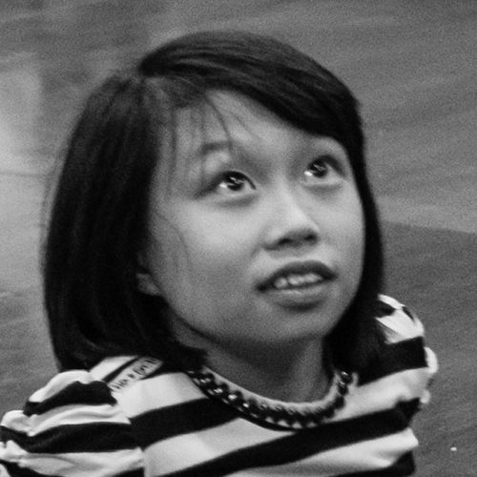  Toh Keow Woon | 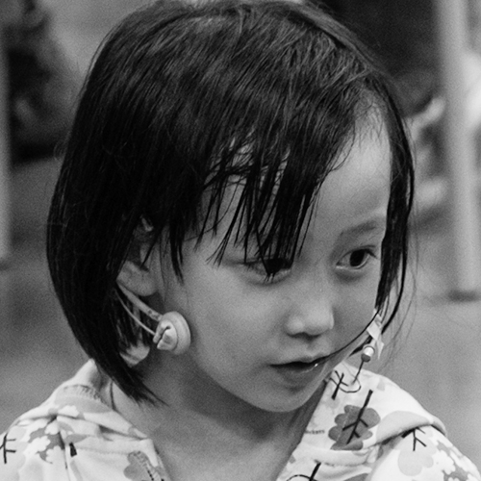  Toh Yun Woon
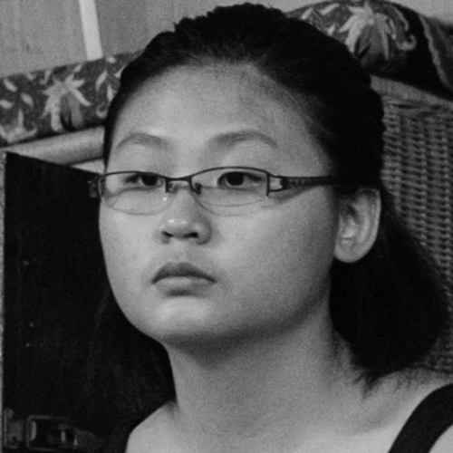  Jasmine Wang | 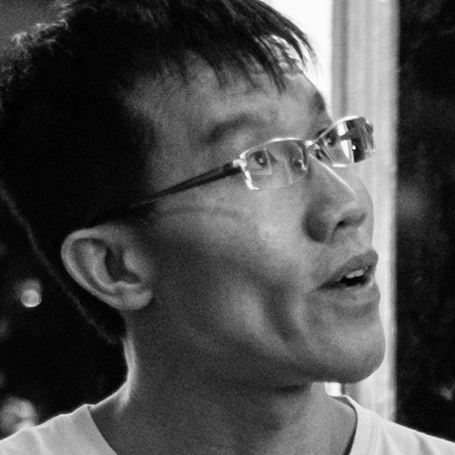  Wong Chee Wai
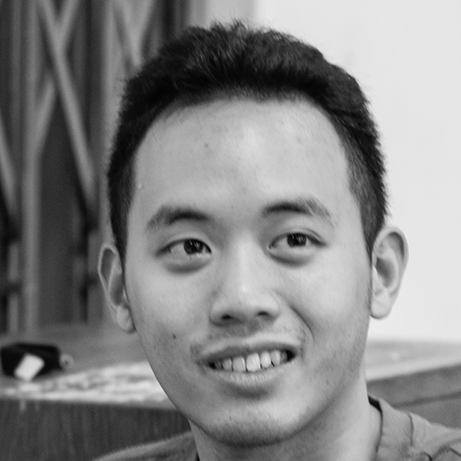  Julian Wong | 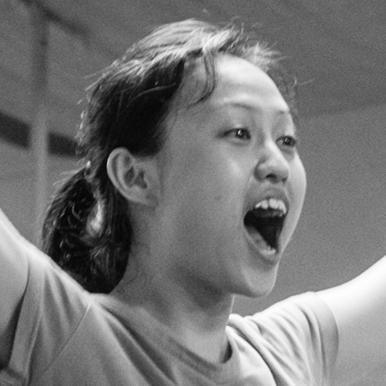  Ethel Yap
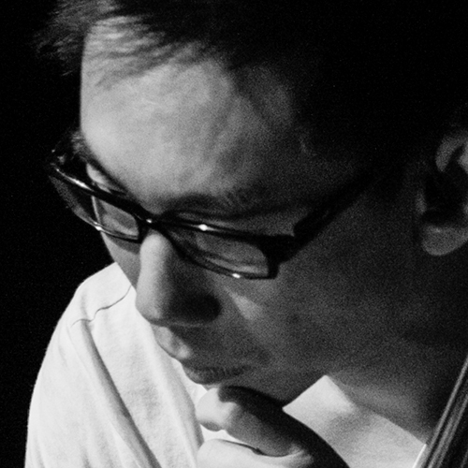
Colin Yong

Process Notes

List of songs – in order of performance

Act I
Someone Lived in a Pretty How Town . . . . . . . . . Ensemble, A-Le
A Song for You . . . . . . . . . A-Le
Always Friends . . . . . . . . . A-Le, Xiao Jing
A Worrying Heart . . . . . . . . . Xiao Jing
The Name of Love . . . . . . . . . Rose
An Autumn Heart . . . . . . . . . A-Le
An Autumn Heart . . . . . . . . . A-Qiang, Ensemble
One Step at a Time . . . . . . . . . Xiao Song, Xiao Jiang, Dishwashing Auntie,
Kitchen Uncle, Ensemble
If You Should Think of Me . . . . . . . . . A-Qiang, A-Le
My Love Takes Root . . . . . . . . . Rose
Summertime* . . . . . . . . . Hip Hop Girls
The Red Bean Poem 2000 . . . . . . . . . A-Le, A-Qiang, Xiao Song, Xiao Jiang
House of the Rising Sun* . . . . . . . . . Hip Hop Girls
Granny’s Da Fu Biscuit . . . . . . . . . A-Le, A-Qiang, Xiao Song, Xiao Jiang
Where Are Our Songs? . . . . . . . . . A-Le, A-Qiang, Xiao Song, Rose, Ensemble
The Sparrow with a Bamboo Twig . . . . . . . . . Dishwashing Auntie, Kitchen Uncle, A-Le,
A-Qiang, Xiao Song, Rose, Ensemble
Loving You . . . . . . . . . Xiao Jing
To Now See the Good in You . . . . . . . . . Jun Qiang
The Shy Rose Blooms Quietly . . . . . . . . . A-Le, A-Qiang, Xiao Song, Xiao Jiang
You Are So Cool . . . . . . . . . Rose
Take Me on a Song . . . . . . . . . A-Le, Ensemble
As the Night Falls Gently . . . . . . . . . Jun Qiang, A-Qiang
From the Day You Looked Back . . . . . . . . . Xiao Jing, Rose

Act II
If There’re Seasons . . . . . . . . . Uncle Cheng, Kids
The Eve of the History Exam . . . . . . . . . A-Le, Kids
YOYO Folk-Song . . . . . . . . . Millie, A-Le, Kids
Words of Water . . . . . . . . . Rose
Speaking of Old Times* . . . . . . . . . A-Qiang
In the End . . . . . . . . . A-Qiang
Sitting In Rows . . . . . . . . . Rose, A-Le
Embrace . . . . . . . . . Rose, A-Le, Xiao Jing
Your Reﬂection . . . . . . . . . A-Le, Xiao Jing
Some You Get, Some You Don’t . . . . . . . . . A-Qiang
A Break from Love . . . . . . . . . A-Le
Another Sweet Song, Another Heart- Breaking Story . . . . . . . . . Rose, A-Qiang, A-Le
From the Day You Looked Back . . . . . . . . . A-Le
To Now See the Good in You . . . . . . . . . A-Qiang
Watch the Sunrise with Me * . . . . . . . . . Rose, A-Le, Xiao Jing
Singapore Pie . . . . . . . . . Ensemble Chorus

*Summertime is composed by George Gershwin and written by Dorothy Hayward, Du Bose Hayward and Ira Gershwin.
*House of the Rising Sun is an American folk song.
*Speaking of Old Times is written by San Mao.
*Watch the Sunrise with Me is composed by BEGIN
(OP:Touch Music Publishing Pte Ltd)

The Theatre Practice – the Company

Board of Directors
Daniel Goh (Co-Chairman)
Samuel Seow (Co-Chairman)
Wong Yen Yee
Quah Sy Ren
Kuo Jian Hong

Staff
Co-Founder /Artistic Advisor . . . . . . . . . Goh Lay Kuan
Artistic Director . . . . . . . . . Kuo jian Hong
Lab Director . . . . . . . . . Liu Xiaoyi
Education and Outreach Advisor . . . . . . . . . Wong May Lan
Resident Director . . . . . . . . . Wu Xi
Resident Artists . . . . . . . . . Deng Chenchao
Hung Chit Wah, Felix
Ng Mun Poh
Stage Manager . . . . . . . . . Gong Zekun
Vivianne Koh
Company Manager . . . . . . . . . Jo Lim
Programme Manager . . . . . . . . . Chang Woon Yong
Yeo Fu Bi
Education Research . . . . . . . . . Wei Shimin
Literary Research . . . . . . . . . Huang Suhuai
Sales and Marketing . . . . . . . . . Karen Boo
Marketing and Communications . . . . . . . . . Jeanne Tan
Graphic Designer . . . . . . . . . Hui Shi Li
Ofﬁce Administrator . . . . . . . . . Rena Lew
Publicist . . . . . . . . . Guo Xiong
Interns . . . . . . . . . Justina Hussain
Shih Xiu Rong

WIP General Editor: Aubrey Mellor

